Atitit [JSqlParser](https://www.baidu.com/link?url=xNBqivk17eyTaVpOE_5KBYmysdbhdPlGamRQaGxCXzLmwdaFKjyBzDQZIrifchn07G8xlT4Q7ZDk3KtTScxmzT11Fc-rKEwmZ7crRo0N9y7&wd=&eqid=c4f8fe0a000a3c9a000000065db3e056" \t "https://www.baidu.com/_blank)生成sql 根据ast

目录

1.1. 解析 1

1.2. 生成where c=111语句 1

1.3. 生成and where语句 2

1.4. Select 聚合函数 3

1.5. Desc语句order排序 4

1.6. 翻页 5

2. ref 6

## 解析

String sql = "select * from tab where c1=123 and c2=456";  
sql = "select * from tab where c1=123 ";  
Select select = (Select) CCJSqlParserUtil.*parse*(sql);  
// System.out.println(JSON.toJSONString(select,true));

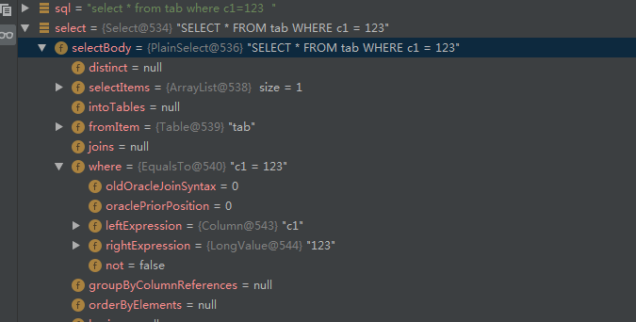

## Select子句

## 生成where c=111语句

Select select2 = SelectUtils.*buildSelectFromTable*(new Table("没啥用"));  
  
// EqualsTo EqualsToExp=new EqualsTo();  
  
  
select2.setSelectBody(new PlainSelect() {{  
  
 setSelectItems(new ArrayList() {{  
 add("*");  
 }});  
 setFromItem(new Table("TABLE1"));  
 setWhere(new EqualsTo() {{  
 setLeftExpression(new Column("c1"));  
 setRightExpression(new StringValue("aaa"));  
 }});  
 }}  
  
  
);  
  
  
// SelectUtils.addExpression(select2,EqualsToExp);  
  
System.*out*.println(select2.toString());//SELECT * FROM TABLE1  
System.*out*.println("--f");

## 生成and where语句

SELECT * FROM TABLE1 WHERE c1 = 'a' AND c2 = 789

Select select_where_and = SelectUtils.*buildSelectFromTable*(new Table("没啥用"));  
  
select_where_and.setSelectBody(new PlainSelect() {{  
  
 setSelectItems(new ArrayList() {{  
 add("*");  
 }});  
 setFromItem(new Table("TABLE1"));  
 setWhere(  
 new AndExpression(new EqualsTo() {{  
 setLeftExpression(new Column("c1"));  
 setRightExpression(new StringValue("aaa"));  
 }}, new EqualsTo() {{  
 setLeftExpression(new Column("c2"));  
 setRightExpression(new LongValue(789));  
 }}) {{  
  
 }}  
 );  
 }}  
  
  
);  
System.*out*.println(select_where_and.toString());//SELECT * FROM TABLE1

## Select 聚合函数

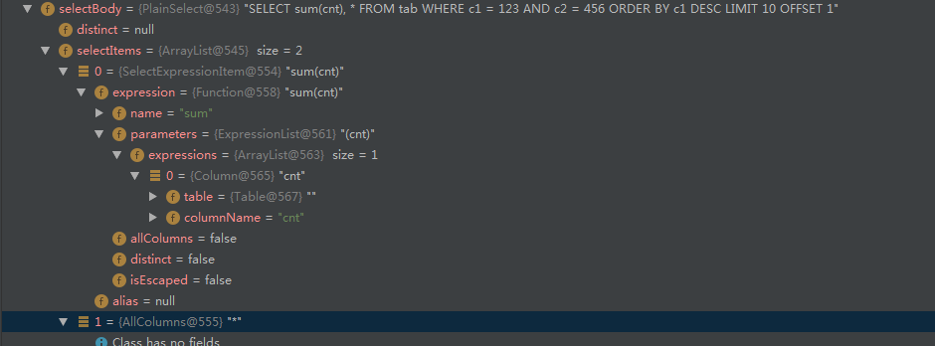

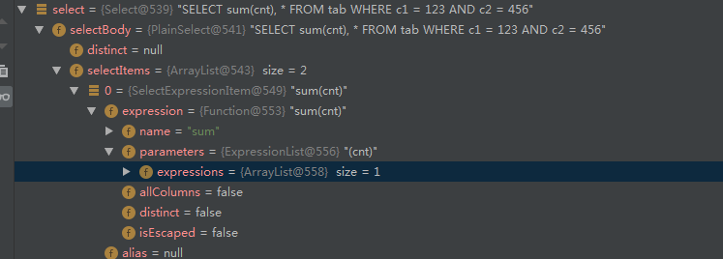

## Desc语句order排序

select2.setSelectBody(new PlainSelect() {{  
  
 setSelectItems(new ArrayList() {{  
 add("*");  
 }});  
 setFromItem(new Table("TABLE1"));  
 setWhere(new EqualsTo() {{  
 setLeftExpression(new Column("c1"));  
 setRightExpression(new StringValue("aaa"));  
 }});  
 setOrderByElements( new ArrayList<OrderByElement>() {{  
 add( new OrderByElement(){{  
 setExpression( new Column("c1") );  
 setAsc(true);  
 setAscDescPresent(false);  
 }});  
 }} );  
 }}

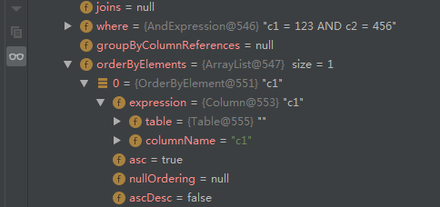

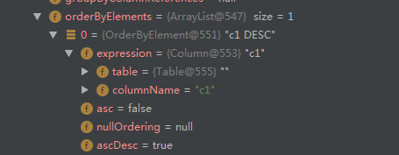

## 翻页

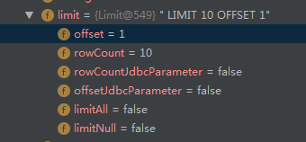

select2.setSelectBody(new PlainSelect() {{  
  
 setSelectItems(new ArrayList() {{  
 add("*");  
 }});  
 setFromItem(new Table("TABLE1"));  
 setWhere(new EqualsTo() {{  
 setLeftExpression(new Column("c1"));  
 setRightExpression(new StringValue("aaa"));  
 }});  
 setOrderByElements( new ArrayList<OrderByElement>() {{  
 add( new OrderByElement(){{  
 setExpression( new Column("c1") );  
 setAsc(true);  
 setAscDescPresent(false);  
 }});  
 }} );  
 setLimit(new Limit(){{  
 setOffset(7);  
 setRowCount(10);  
 }});  
 }}  
  
  
);

SELECT * FROM TABLE1 WHERE c1 = 'a' ORDER BY c1 LIMIT 10 OFFSET 7

# ref

JSqlParser——SQL语法解释器使用记录：创建SQL语句 - Gigaplant的博客 - CSDN博客.html

Atitit 不错的ql选型 jpql